International Plastics Inc. Network Diagrams

University of Phoenix
CMGT/555: Systems Analysis And Development
Jamal Johnson
Professor: Michael Goyden
December 23rd, 2024

China Headquarters: Proposed Network
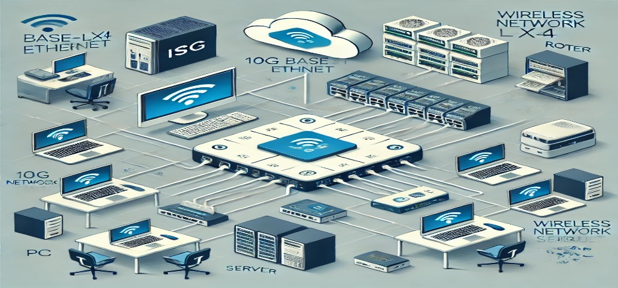
Network Upgrades
- Router and Firewall: Upgrade the existing router to a more advanced model that supports higher throughput, QoS (Quality of Service), and enhanced security protocols. Integrate a next-generation firewall (NGFW) with IDS/IPS to provide proactive threat detection.
- Switching Infrastructure: Replace the current switch with a managed, high-performance Layer 3 switch. This allows for VLAN implementation to segment traffic and provide better bandwidth utilization.
- Wireless Network: Upgrade access points to Wi-Fi 6/6E to support higher device density, improved speed, and better security.
- Scalability Enhancements: Implement server virtualization or use edge computing devices to handle increased demands efficiently.
- Redundancy and Failover: Introduce redundant routers, power supplies, and backup ISP connections to ensure reliability.
- Improved Endpoints: Upgrade older PCs, servers, and network storage systems with newer models capable of handling increased traffic and workloads.
Risks and Mitigations
- Downtime: Upgrades might disrupt operations. To mitigate this, schedule maintenance during non-peak hours and maintain a backup plan for service continuity.
- Data Loss: Configuration changes might compromise sensitive data. Regularly back up data and encrypt configurations to ensure safety.
- Compatibility Issues: New hardware/software may not integrate seamlessly. Test all changes in a simulated environment before deployment.
- Cost Overruns: Upgrades can exceed the budget. Conduct detailed planning and include contingency funds for unforeseen expenses.
- Human Error: Misconfigurations can create vulnerabilities. Provide training to IT staff and establish robust testing protocols before implementation.
This upgrade will modernize the network, ensuring scalability, improved performance, and security while managing potential risks proactively.

Albany, GA: Proposed Network

Network Upgrade Plan
- Upgrade Internet Connection: Replace the T2 connection with a modern high-speed fiber-optic or gigabit Ethernet line to handle increased data traffic and improve reliability.
- Switch Upgrade: Replace the 24-port Cisco switch with a managed Layer 3 switch to support better traffic segmentation, VLANs, and advanced routing.
- Server Upgrade: Upgrade or replace the HP BL460P blade server to a newer model with higher processing power, memory capacity, and virtualization capabilities.
- Storage Solution: Replace the local NAS with a hybrid cloud storage solution for better data accessibility, scalability, and disaster recovery.
- Power Backup Enhancements: Upgrade the 5KVA UPS to a higher-capacity model, possibly with network monitoring capability, to ensure stable power for the increased equipment load.
- Network Redundancy: Add redundant routers, switches, and backup ISPs to prevent downtime in case of a failure.
- Wireless Network Expansion: Add Wi-Fi 6 access points to provide wireless access for mobile devices and improve flexibility on the factory floor.
- Endpoint Upgrades: Upgrade the office computers to modern systems with updated operating systems, better network interfaces, and enhanced security features.

Risks and Mitigations
- Downtime During Upgrades:
  - Risk: Upgrading devices or the network might cause operational disruptions.
  - Mitigation: Schedule upgrades during non-peak hours, maintain a temporary backup connection, and create a rollback plan.
- Cost Overruns:
  - Risk: New equipment and services might exceed budget constraints.
  - Mitigation: Perform a detailed cost analysis, prioritize critical upgrades, and include a contingency fund.
- Configuration Errors:
  - Risk: Misconfigurations in new switches or servers can introduce vulnerabilities or cause performance issues.
  - Mitigation: Test configurations in a sandbox environment, and have experienced IT professionals oversee the changes.
- Compatibility Issues:
  - Risk: New equipment may not integrate smoothly with legacy hardware or software.
  - Mitigation: Conduct compatibility tests beforehand and plan phased replacements of older systems.
- Data Loss or Breaches:
  - Risk: During migration or updates, data may be lost or exposed to security risks.
  - Mitigation: Ensure data backups are up-to-date, use encryption during transfers, and perform audits post-upgrade.
- Scalability and Future Proofing:
  - Risk: Upgrades might not accommodate future growth, leading to recurrent expenses.
  - Mitigation: Choose scalable solutions, such as modular switches and cloud-based services.
With these improvements and proactive measures, the upgraded network will support better performance, scalability, and reliability while mitigating potential risks effectively.

Pontiac: Proposed Network

Network Upgrade Plan
- Upgrade the Internet Connection: Replace the outdated T2 connection with a high-speed fiber-optic or gigabit Ethernet line to handle the increased traffic generated by 45 office computers and factory operations.
- Switch Replacement: Replace the 24-port Cisco switch with a high-performance managed Layer 3 switch or multiple switches to accommodate future growth and enable network segmentation (e.g., VLANs for different departments or factory systems).
- Server and NAS Upgrade: Update the HP BL460P blade server with a more powerful, modern blade server that supports virtualization and advanced storage management. Replace the local NAS with a hybrid cloud storage solution to improve redundancy and scalability.
- Wireless Access Implementation: Deploy Wi-Fi 6 access points to offer wireless connectivity for mobile devices and improve flexibility on the factory floor.
- Power Backup: Upgrade the 5KVA UPS to a higher capacity UPS system (e.g., 10KVA), with intelligent network monitoring, to handle the increased demand from upgraded equipment.
- Endpoint Upgrades: Upgrade office computers with modern hardware and operating systems to optimize network performance and reduce compatibility issues.
- Redundancy and Security Enhancements: Add redundant routers and switches, and implement a next-generation firewall with intrusion detection and prevention (IDS/IPS).

Risks and Mitigations
- Downtime During Upgrades:
  - Risk: Network outages could disrupt office and factory operations during upgrades.
  - Mitigation: Schedule upgrades during off-peak hours or weekends. Maintain a rollback plan and ensure backup connections are available.
- Compatibility Issues:
  - Risk: Legacy devices and software might not integrate with upgraded equipment.
  - Mitigation: Conduct thorough compatibility tests before deployment and replace or update any incompatible components.
- Data Loss During Migration:
  - Risk: Data migration to upgraded storage systems or cloud environments could result in data loss or corruption.
  - Mitigation: Perform full backups before migration, verify data integrity post-migration, and test recovery protocols.
- Security Vulnerabilities:
  - Risk: Introducing new equipment or network configurations could create security gaps.
  - Mitigation: Regularly audit the network, apply patches promptly, and configure advanced security protocols on all devices.
- Budget Overruns:
  - Risk: Costs could exceed initial estimates due to unforeseen expenses.
  - Mitigation: Perform detailed budgeting with contingency allocations, prioritize critical upgrades, and phase non-urgent updates.
- Human Error in Configuration:
  - Risk: Incorrect configurations of new switches or servers could lead to performance or security issues.
  - Mitigation: Have experienced IT professionals manage upgrades, test setups in a sandbox environment, and document all changes.
- Underestimating Future Needs:
  - Risk: The new infrastructure might lack scalability to support future growth.
  - Mitigation: Invest in scalable solutions, such as modular servers, expandable switches, and cloud storage.
By following this plan and implementing mitigations, the upgraded network will provide increased reliability, scalability, and performance, supporting the company's current and future demands effectively.
Corporate: Proposed Network

Network Upgrade Plan
- Upgrade Network Backbones:
  - Replace the 100baseT backbone for administration with at least 1000baseT (Gigabit Ethernet) to improve data transfer rates and reduce latency for VoIP phones and administration computers.
  - Upgrade the existing 10000baseF backbone for R&D to 25000baseF (25 GbE) to future-proof and support demanding tasks like high-end printing and data sharing.
- Administration Updates:
  - Enhance computers used by HR and corporate functions with upgraded hardware to support modern software and cybersecurity measures. Ensure compatibility with enhanced network speeds.
- VoIP Infrastructure:
  - Replace or update the 36 VoIP telephones with models that support modern VoIP protocols and quality improvements like HD voice. Replace or upgrade the VoIP router to ensure minimal latency and seamless voice communication.
- R&D Enhancements:
  - Upgrade high-end printers and the plotter to models with built-in networking capabilities for better integration into the upgraded backbone.
- Servers and NAS Enhancements:
  - Replace older servers with modern blade servers (e.g., IBM Flex System) or transition to hybrid cloud infrastructure to enhance scalability and performance.
  - Upgrade the NAS to accommodate higher storage and faster read/write speeds.
- UPS and Power Backup:
  - Replace the UPS with a higher-capacity model to handle new infrastructure loads, with intelligent monitoring and modular battery expansion.
- Communication Systems:
  - Upgrade the T3 router to a router that supports OC3 (155 Mbps) or higher bandwidth to meet current and future external communication demands.
  - Ensure satellite communication links maintain or enhance end-to-end encryption and provide better redundancy.
- Security and Firewalls:
  - Replace the firewall with a next-generation firewall (NGFW) to detect and mitigate threats efficiently. Add intrusion detection/prevention systems (IDS/IPS) across critical network points.

Risks and Mitigations
- Compatibility Issues:
  - Risk: New systems may not integrate with legacy hardware.
  - Mitigation: Test upgrades in phases, starting with smaller components, and implement backward-compatible solutions where necessary.
- Downtime:
  - Risk: Upgrades, especially in communication systems, could disrupt operations.
  - Mitigation: Schedule changes during non-peak hours and ensure temporary backup connectivity is available.
- Data Loss or Corruption:
  - Risk: Moving or updating servers and NAS might result in data corruption or loss.
  - Mitigation: Perform full data backups, verify them, and conduct integrity checks post-upgrade.
- Security Vulnerabilities:
  - Risk: Introducing new equipment could create unforeseen security gaps.
  - Mitigation: Immediately patch all systems post-installation, and run vulnerability assessments to address risks.
- Cost Overruns:
  - Risk: Budget may exceed projections due to additional expenses for unexpected equipment.
  - Mitigation: Perform detailed cost analysis upfront, identify critical upgrades, and maintain contingency funds.
- Human Error in Configuration:
  - Risk: Incorrect configurations can lead to performance issues or security lapses.
  - Mitigation: Involve experienced IT personnel, conduct training, and validate all configurations with thorough testing.
- Scalability Concerns:
  - Risk: The upgraded network may not accommodate future growth.
  - Mitigation: Choose equipment with scalability in mind, such as modular switches, hybrid cloud solutions, and expandable server infrastructure.

These upgrades will modernize the network to support existing workloads while preparing it for future demands. Mitigating risks proactively ensures reliability, performance, and security throughout the upgrade process.

